**Chapter 1 - Digestive System**

**All Lectures Uploaded on YouTube:**

[**https://tinyurl.com/fkm10-biology**](https://tinyurl.com/fkm10-biology)

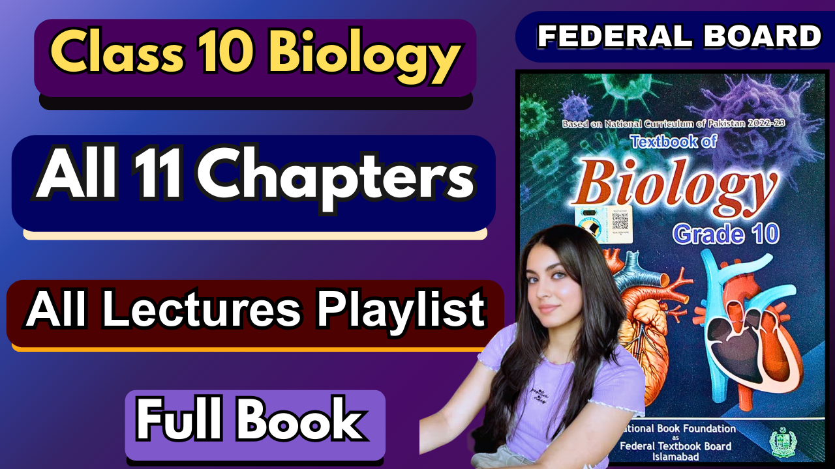

**1.1. Ingestion, Digestion, Absorption, Assimilation, and Egestion**

* Man needs energy for all life processes, which comes from the metabolism of food substances that are digested.
* Food consists of carbohydrates, proteins, and fats, which are all large molecules.
* The main functions/processes of the digestive system are: **ingestion, digestion, absorption, assimilation, and egestion**.

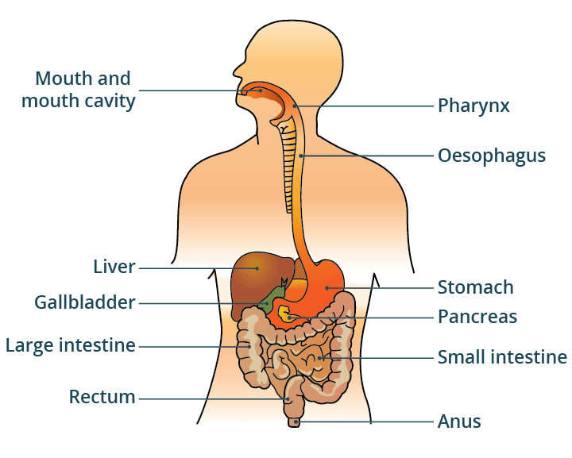

**Ingestion:** taking in food

**Digestion:** breakdown of large food molecules into small soluble food molecules with the help of enzymes

**Absorption:** passing down of digested food into the blood from the digestive tube

**Assimilation:** the taking up of molecules by the cells to be utilised for other purposes

**Egestion:** removal of the undigested part of food by the body

**1.2. Human Alimentary Canal**

There are two sets of organs which make up the human digestive system:

1. **The alimentary canal** (also called the gastrointestinal canal) consists of the mouth, the oral cavity, the pharynx, the oesophagus, the stomach, the small intestine and the large intestine. These parts are concerned with the ingestion, digestion, absorption and egestion of food.
2. **Digestive glands**: these include the salivary glands, gastric glands, intestinal glands, liver and pancreas, which are not directly linked with digestion but help the alimentary canal in the process.

**1.2.1. Alimentary Canal**

**Alimentary Canal:**

* Also known as: Gut, Digestive Tract, or **Gastrointestinal Tract.**
* It is a **continuous tube**, about **9 meters** long for adults.
* Specialized at various points for digestion and absorption.
* Begins at the **mouth**, ends at the **anus**, and is internally lined by **mucous membrane.**
* Each region performs a different function in the overall digestion process.

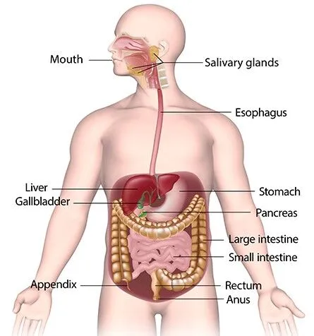

### **1. Mouth**

* Entry point to the oral cavity/mouth cavity.
* Contains:  
  - **Teeth**- **Tongue**

### **2. Oral Cavity**

* Surrounded by:
  + **Upper and lower jaws**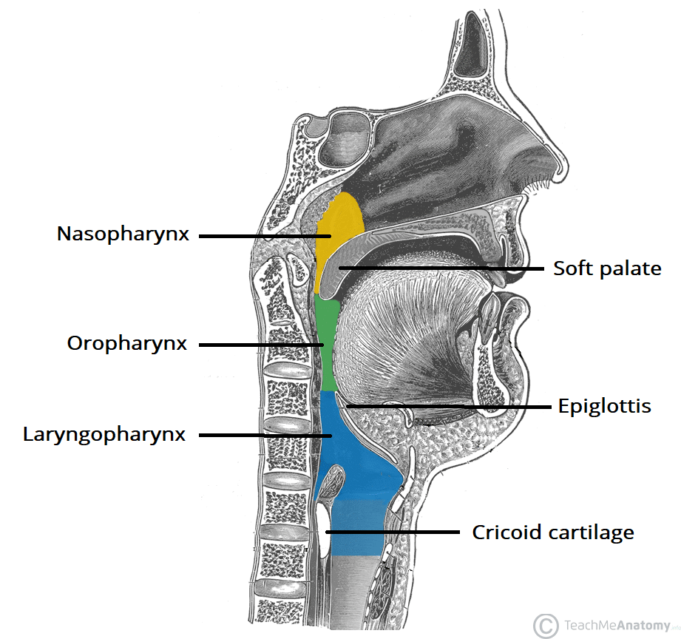
* The upper jaw is fixed; the lower jaw is movable.
* Starts digestion mechanically (chewing) and chemically (saliva).

### **3. Pharynx**

* Common passage for food and air.
* Connects the mouth and the nasal cavity to:  
  - **Oesophagus** (for food)  
  - **Trachea** (for air)

### **4. Oesophagus**

* Tube-like structure ~25 cm long.
* Connects the pharynx to the stomach.
* No digestion occurs here

### **5. Stomach**

* **J-shaped** and located on the **left side of the abdominal cavity**, below the diaphragm.
* Divided into 3 parts:  
  - **Cardiac region**: Connected to the oesophagus.  
  - **Fundus**- **Pyloric region**: Connected to the small intestine.

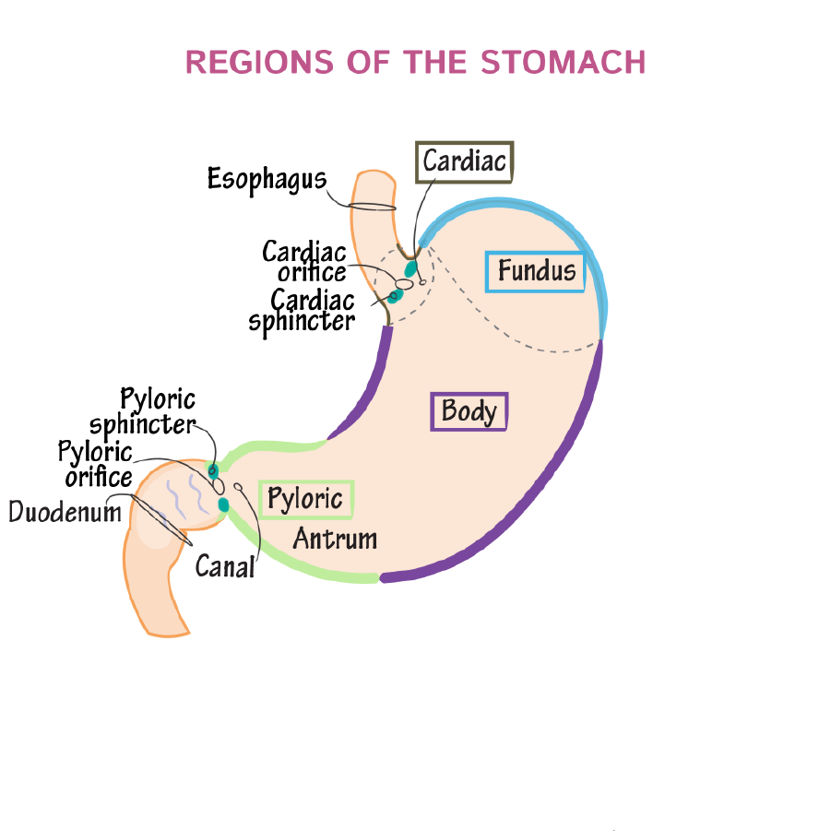

#### **Openings and Sphincters:**

* Opening from the **oesophagus** to the **stomach**:  
  - Called the **cardiac opening**.  
  - Guarded by **cardiac sphincter**.
* Opening from the **stomach** to the **duodenum**:  
  - Called the **pyloric opening**.  
  - Guarded by **pyloric sphincter**.

### **6. Small Intestine**

* Longest part of the alimentary canal.
* Diameter: **Small** (hence the name).
* Length: About **6 meters**.
* Divided into 3 parts:  
  + **Duodenum** (~25 cm): U-shaped; receives:  
    - Bile duct from the liver/gall bladder.  
    - Pancreatic duct from the pancreas.
  + **Jejunum**
  + **Ileum**

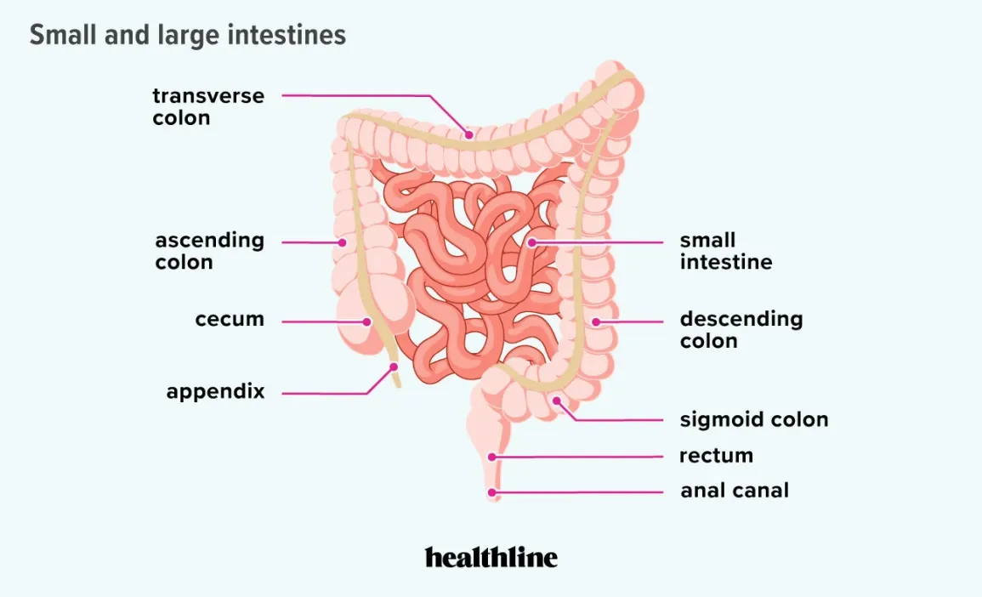

### **7. Large Intestine**

* Shorter but **wider** than the small intestine.
* Length: About **1.5 meters**.
* Divided into:  
  + **Caecum**: Pouch-like; contains **vermiform appendix**.
  + **Colon**: Has 4 parts—  
    - Ascending  
    - Transverse  
    - Descending  
    - Sigmoid
  + **Rectum**: Leads to **anus** for excretion.

**1.2.2. Associated Organs**

These aid digestion but are not part of the alimentary canal.  
Includes: **Teeth, tongue, salivary glands, liver, gallbladder, pancreas**

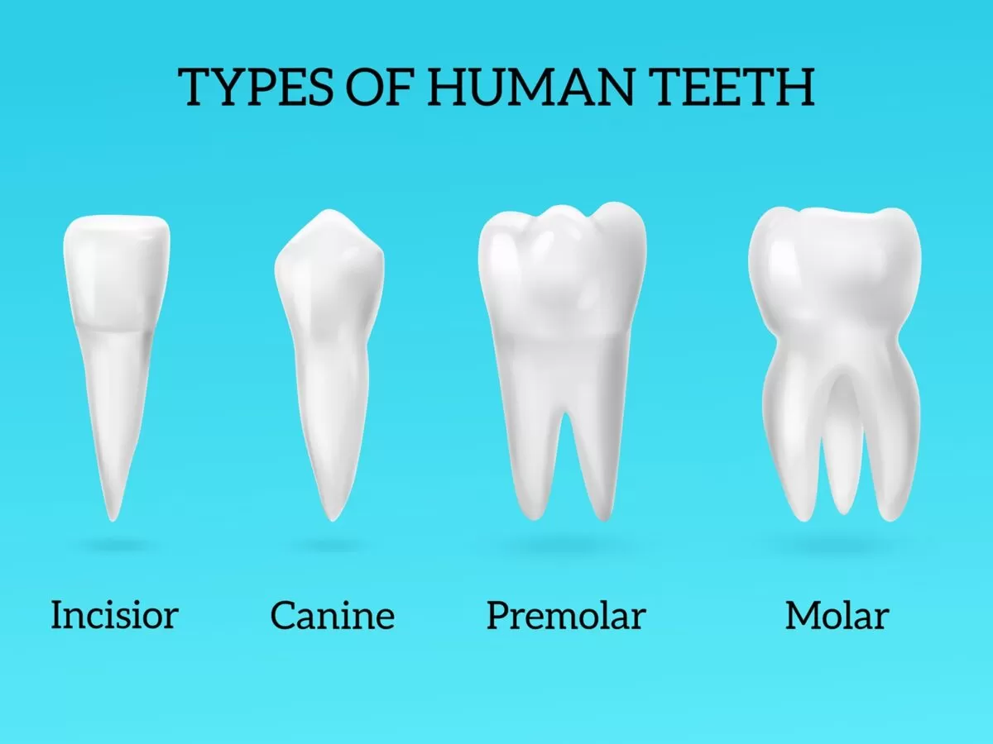

### **1. Teeth**

* Function: Helps in the **mechanical breakdown** of food.
* **4 Types**:
  + **Incisors**: Cutting food.
  + **Canines**: Tearing food.
  + **Premolars**: Crushing food.
  + **Molars**: Grinding food.
* **Arrangement**:  
  - Incisors and canines are located at the **front**.  
  - Premolars and molars are at the **back**.
* Humans have **two sets**: milk teeth and permanent teeth.

### **2. Tongue**

* A **muscular organ** in the mouth cavity.
* Functions:
  + Helps in **chewing**, **swallowing**, and **speaking**.
  + Assists in **taste perception**.
* The upper surface contains **taste buds**:
  + **Umami**: Middle-back area.
  + **Sweet**: Tip of the tongue.
  + **Salty**: Tip sides.
  + **Sour**: Side-middle.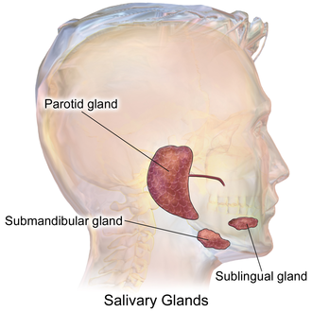
  + **Bitter**: Rear.

### **3. Salivary Glands**

* Produce **saliva**, which:
  + Moistens food
  + Begins **chemical digestion** (contains the enzyme **salivary amylase**)
* 3 Main pairs:
  + **Parotid glands**: Below and in front of the ears.
  + **Submandibular glands**: Below the lower jaw.
  + **Sublingual glands**: Below the tongue.
* Saliva also helps in:
  + **Swallowing** food
  + **Cleaning** the mouth and teeth

**4. Liver**

* **The largest gland** in the body.
* Shape: **Wedge-shaped**, reddish-brown.
* Location: Upper right side of the abdomen, below the diaphragm.
* Structure:
  + Two main lobes:
    - **Right lobe** (larger)
    - **Left lobe** (smaller)
* Functions:
  + Produces **bile**
  + Helps in **fat digestion and absorption**

### **5. Gallbladder**

* A small, **pear-shaped** sac located under the liver.
* **Stores and concentrates bile** produced by the liver.
* Releases bile into the **duodenum** through the **bile duct**.

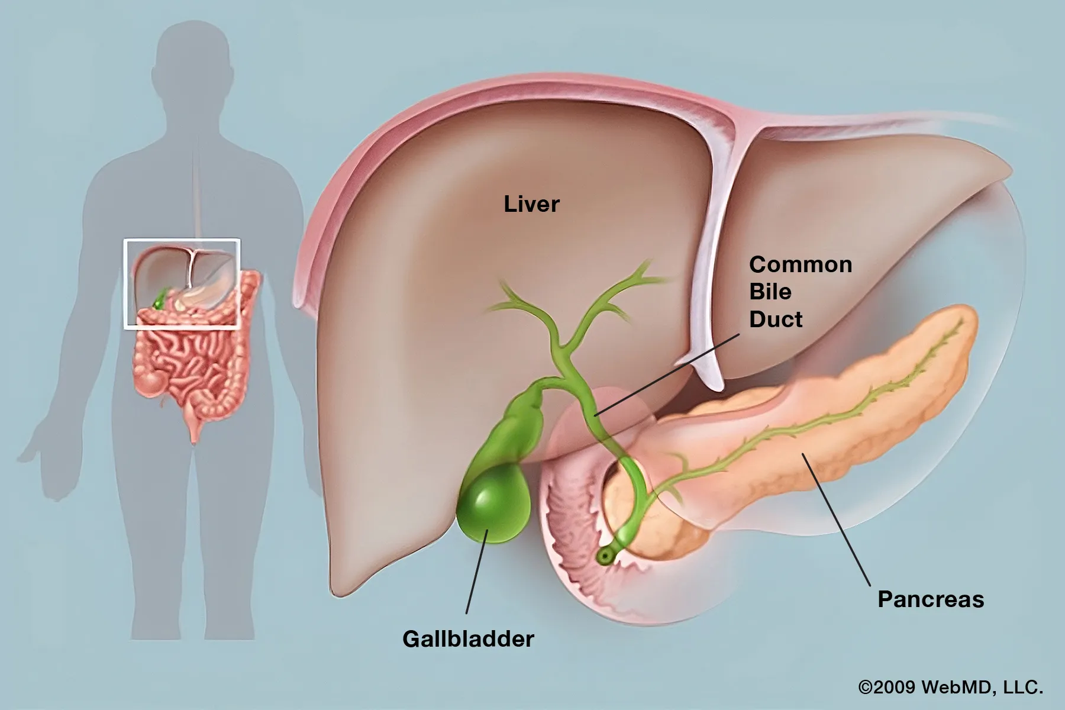

### **6. Pancreas**

### A soft, **leaf-shaped** gland.

### Location: Below the stomach and behind the peritoneum; lies horizontally.

* Dual Function:  
  - **Exocrine part**: Secretes digestive enzymes into the **duodenum**.  
  - **Endocrine part**: Releases insulin and glucagon into the blood.
* Connected to the duodenum via the **pancreatic duct**.

**1.3. Swallowing and Peristalsis**

**1.3.1. Swallowing:**

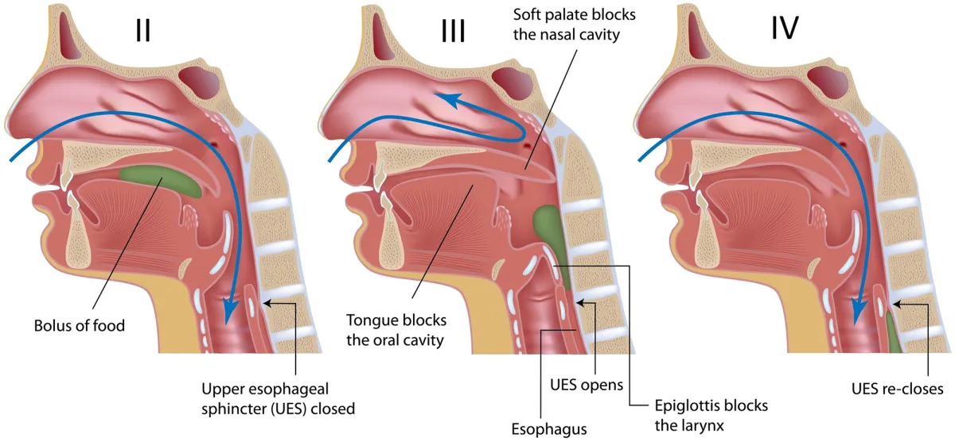

### **1. Oral Preparatory Phase (Voluntary)**

* The **tongue** pushes the food (bolus) **upwards and backwards** toward the roof of the mouth.
* This action moves the bolus to the back of the oral cavity.

### **2. Oral Transport Phase**

* The **soft palate** (roof of the mouth) **closes the nasal cavity**.
* This prevents food from going into the nose.

### **3. Pharyngeal Phase**

* The **larynx (voice box)**, which is located on top of the **trachea** (windpipe), is pulled **upward.**
* The **glottis** (opening of the trachea) is, therefore located at the **back of the tongue**.
* This helps protect the airway.

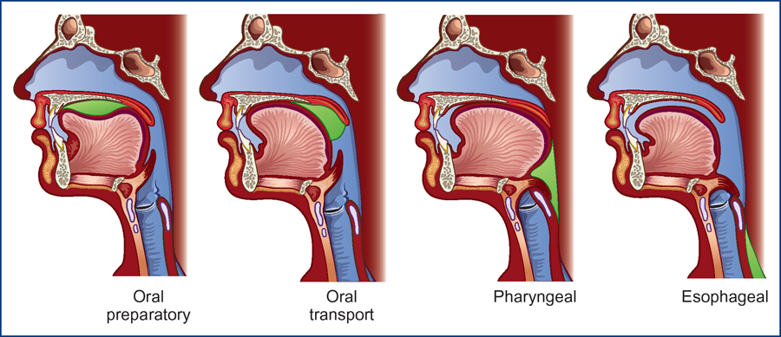

### **4. Esophageal Phase**

* The **epiglottis** (a flap of cartilage) **close the glottis**.
* This prevents food from entering the trachea (windpipe) and directs it to the oesophagus.

Swallowing **starts voluntarily**, but once food reaches the back of the mouth, it becomes **automatic** and cannot be stopped.

## **1.3.2. Peristalsis**

* Peristalsis is a wave-like muscular movement that pushes food forward through the alimentary canal (digestive tract).

1. **Circular muscles** (around the tube) **contract behind the bolus**.
   * This **squeezes** the food forward.
2. **Longitudinal muscles** (lengthwise) **contract in front of the bolus**.
   * This **widens the next part** of the oesophagus.
3. These **alternating contractions** create a **rhythmic wave** that moves the food smoothly.

This process continues from the **oesophagus to the** **rectum**, helping move food and waste throughout the body.

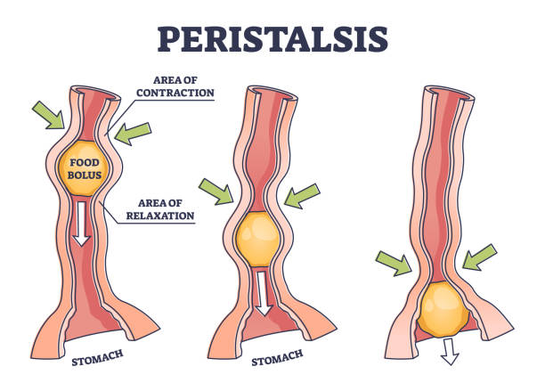

**1.4. Chemical Digestion:**

**1.4.1. Digestion in the Oral Cavity**

* Food is tasted, smelled, and felt.
* **Mechanical digestion**: Teeth, cheeks, and tongue help in crushing and grinding.
* **Salivary glands** secrete saliva (which contains water, mucus, and enzymes).

1. **Salivary amylase**: Converts starch into maltose.
2. **Lipase**: Breaks triglycerides into diglycerides and free fatty acids.

* Food becomes a **bolus** and passes to the oesophagus through the **pharynx**.

**1.4.2. Digestion in the Stomach:**

* The **cardiac sphincter** relaxes to allow food entry into the stomach.
* **Gastric Juice** contains:

1. **HCl** (Hydrochloric acid)

* Stops salivary amylase
* Converts **pepsinogen** (inactive) to **pepsin** (active)
* Kills microorganisms

1. **Pepsin**: Digests proteins to polypeptides and peptides.
2. **Rennin** (only in infants): Helps digest milk protein.

* **Mucus**: Protects the stomach lining from HCl.
* Food turns into **chyme** (semi-liquid), and when acidic enough, it moves to the duodenum via the **pyloric sphincter.**

**1.4.3. Digestion in the Small Intestine:**

* Enzymatic digestion of starch, proteins, and fats.
* Chyme triggers:  
  (a) Gall bladder → **Bile**(b) Pancreas → **Pancreatic juice**(c) Intestinal glands → **Intestinal juice**

#### **Bile**

* Greenish-yellow liquid from the liver.
* Stored in the gall bladder.
* **Emulsifying fats** (breaks into small droplets) → increases the surface area for enzyme action.

#### **Pancreatic Juice**

* Contains: **Amylase, Lipase, Trypsinogen**
  + **Amylase**: Polysaccharides → Maltose → Glucose
  + **Lipase**: Triglycerides → Glycerol + Fatty acids
  + **Trypsinogen**: Activated to **Trypsin** → Proteins → Polypeptides

#### **Digestion in Jejunum & Ileum**

* Enzymes:
  + **Erepsin**: Peptides → Amino acids
  + **Enterokinase**: Activates trypsinogen
  + **Lactase**: Lactose → Glucose
  + **Maltase**: Maltose → Glucose
* Digestion completes in the **ileum**. (last part of the small intestine)

**1.4.4. Absorption in the Small Intestine:**

* The internal wall has **villi** (increase surface area).
* **Simple sugars** and **amino acids** → blood capillaries.
* **Fatty acids** and **glycerol** → **lacteals** (lymph capillaries).
* Absorption uses diffusion and active transport.
* Nutrients → Capillaries → Veins → Hepatic portal vein → Liver

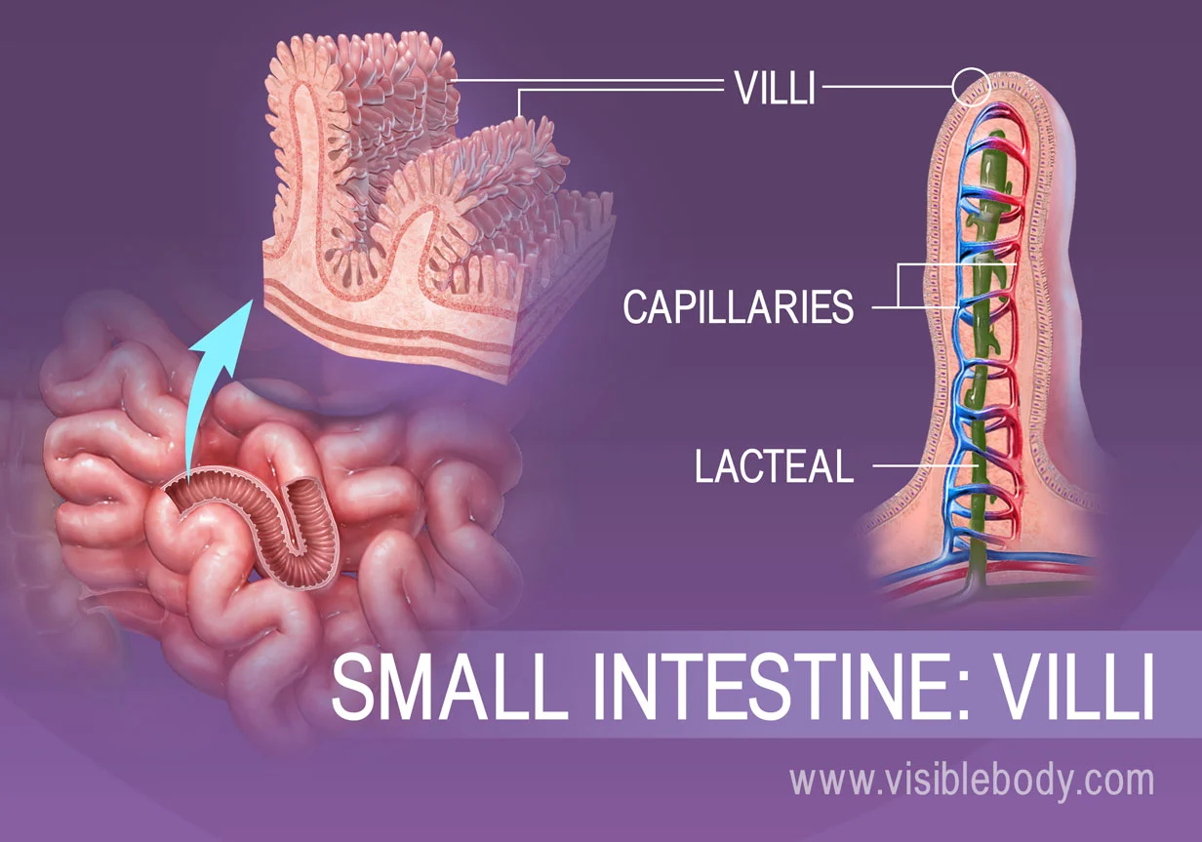

**1.4.5. Absorption in the Large Intestine:**

* Water and some vitamins are absorbed into the blood.

### **1.4.6. Assimilation**

* Absorbed nutrients are used by body cells to produce **ATP**.
* Glucose, amino acids, and fats → cellular respiration.

### **Defecation**

* Undigested waste (feces) is expelled through the **rectum and anus**.
* This process is called **egestion or defecation**.

**1.5. Role of the Liver:** 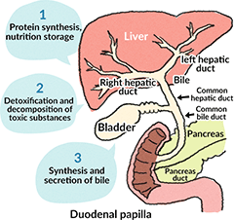

* These are the most important functions of the liver:

1. Manufactures bile.
2. Stores glucose as **glycogen**.
3. Converts glycerol and amino acids to glucose.
4. **Deamination**: Removes the amino group → **Urea**.
5. Synthesises plasma proteins.
6. Destroys old red blood cells.
7. Stores vitamins (A, D, E, K) and minerals (iron).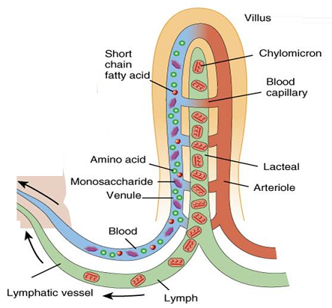

**1.6. Structure of the Villus:**

* Found in the **small intestine**.
* Covered by **simple columnar epithelium**.
* Contains:
  + **Blood capillaries** (absorb glucose and amino acids)
  + **Lacteal** (absorbs fatty acids & glycerol)
  + **Goblet cells** (secrete mucus)
  + **Intestinal crypts** (glands with stem cells)
  + **Arteriole, venule, lymph vessel**

**1.7. Disorders of Gut**

**Gut Disorders:**

### **Diarrhoea**

* Watery stools, increased frequency.
* Causes: GI infection, nervous stimulation, food poisoning.
* Results in dehydration.
* Treatment: ORS (Oral Rehydration Solution)

### **Constipation:**

### Hard, infrequent stools.

### Causes: Low fibre, low water, medication, inactivity.

### Prevention: High fibre diet, water, exercise.

### Called "the mother of all diseases".

### **Ulcer**

### Open sore in the stomach (gastric) or duodenum (peptic).

### Caused by: Acidity, smoking, and bacterial infection.

### Prevention: Avoid spicy food, acidic food, and stress.



